Capstone Project Proposal Guide
* This guide is meant as an aid in gathering the information needed to describe a capstone project. Please submit your project through iCareers when ready (see section below for instructions). For examples of past capstone projects and a recap of last year’s event, please visit https://ischool.uw.edu/capstone.

Step 1: Gather Information

Name of sponsoring organization:
Contact Information:  For staff who will serve as primary point person for the Capstone project and help students access information and resources needed to execute the project | Name:
 | Title:
 | Email:
 | Phone:

Project Description:

1-2 paragraphs describing the specific information challenge that you would like students to address in their capstone. You may include context, background, and scope of the project if known.

Project Deliverables:

Brief statement of the deliverables desired as a result of the project. Examples: written presentation, oral presentation, mobile application, or a data visualization.

Special Considerations:

Any conditions or restrictions that may be applicable (team size, restrictions on public display of company or project info, work authorization restrictions, intellectual property, etc)

Skills/Requirements:

Specific skills or knowledge needed to successfully complete the project.

Class Level:

Would you like applications from Informatics undergraduate students or from MSIM/MLIS masters students?

Other questions to consider:
- How you’d like to receive applications (email, accumulate via iCareers, or other means like an internal hiring website)
- Additional required documents for application (cover letter, writing sample, unofficial transcript, references, etc)

Step 2: Post Your Capstone on iCareers

Create an Account / Sign in to iCareers
If this is your first time interacting with iCareers you will first need to create an account at https://ischool-uw-csm.symplicity.com/employers/.
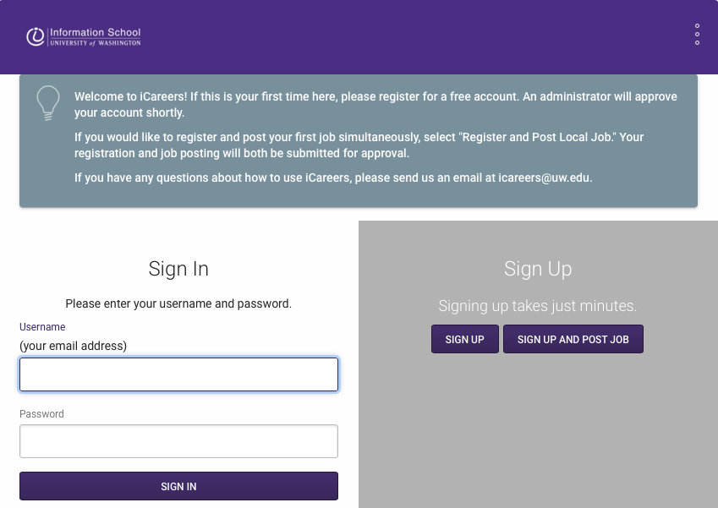
Screenshot of the Employers login screen of iCareers.
- Click "Sign Up and Post Job.” Your request for an account and Capstone posting will be approved at the same time. (If you already have an iCareers account, you can log in with the same link above.)
- Enter your organization/company’s information to register for iCareers. Click Next.

Enter Capstone Proposal Details
After entering your company’s iCareers account information you will “Sign Up and Post Job.”
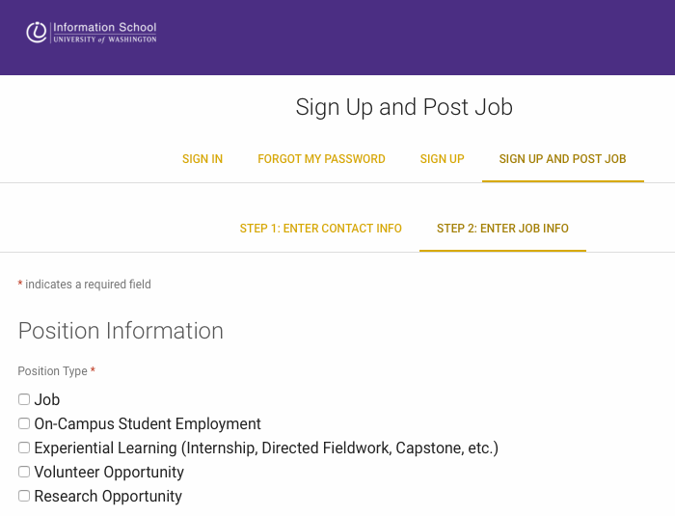
Screenshot of Job Posting screen.

Fill in required and optional position information – if you need additional guidance on required fields, see below:
- Select Position Type: Experiential Learning (Internship, Directed Fieldwork, Capstone)
- Work Term: select “Winter 2020” – You won’t see this option until you select Experiential Learning above.
- Experiential Learning Type: Select “Capstone” – You won’t see this option until you select Experiential Learning above.
- Title: Fill in title of project
- Job or Project Description: fill in from Project Description above
- Qualifications and Skills: fill in all applicable skills from Skills / Requirements section above
- Special Considerations: fill in all applicable considerations from section above
- Number of Openings: Students working with a sponsoring organization generally work in groups of 2-4, and may choose their teams. If no preference for team size, choose 4.
- Compensation Information: Choose all options that apply. Capstones are eligible for credit.
- Location: fill in address for sponsoring organization
- Resume Receipt: Choose how you would like to receive student resumes for the posted Capstone project (email, accumulate online, or other option)
- Posting/Expiration Date: You may post Capstone project immediately or choose September 25, 2019 (first day of fall quarter). For expiration, choose December 20, 2019, as default (students are required to select their Capstone projects by mid-December), or earlier depending on organization need.
- Class Level: You can restrict applications to only particular class levels. If you only want applications from Informatics students, choose Undergraduate - Junior and Undergraduate - Senior. For MSIM or MLIS students, choose Masters – Second/Final Year. Please note that students in other class levels will not be able to apply if you enter a value in this field.
Adding a new Capstone Proposal to an existing iCareers account
Sign in as usual to iCareers: https://ischool-uw-csm.symplicity.com/employers/
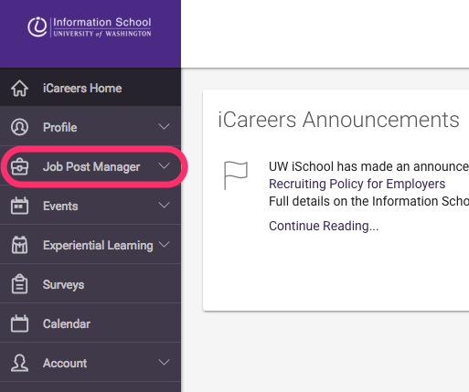
Screenshot of main iCareers page with Job Post Manger highlighted
To post a Capstone project, select "Job Post Manager" from the menu. Then select “Job Postings.”
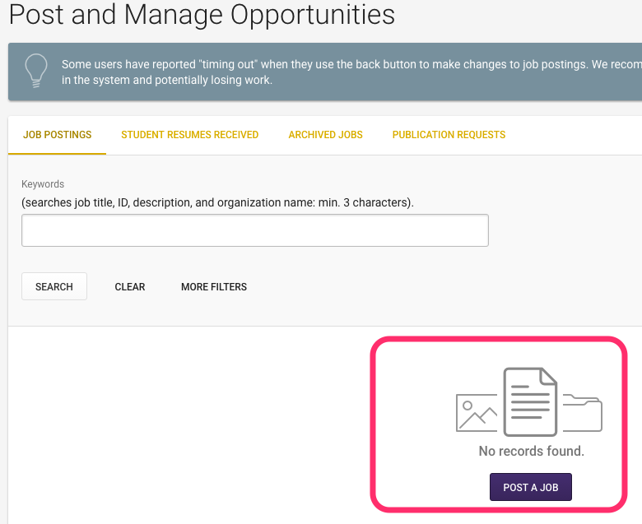

Then click the "Post a Job" button. Select “Post to This School Only” and then follow the steps listed on page 3 to complete your Capstone Proposal posting.

