

***Welcome to our third annual iSchool Diversity Month!***

***Please see the attached Diversity Month calendar for events and descriptions***

**Week 1:**

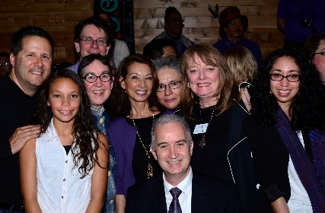

***Diversity Month Kick Off Lunch and Get Acquainted/Allyship Activity***

***Facilitated by iSchool student groups! Join us!***

**Tuesday, November 7, 2017**

**12:00-1:30pm- Lunch provided!**

**wǝɫǝbʔaltxʷ – Intellectual House**

[***Please RSVP for headcount, dietary restrictions/preferences***](https://catalyst.uw.edu/webq/survey/irecruit/342252)

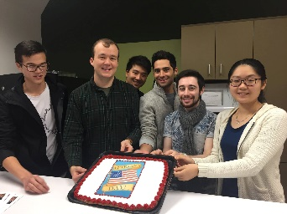

**Diversity Power Hour Lunch**

***Veterans and Military Families at the iSchool:***

***Civilians’ Do’s and Don’ts AND***

***What have you always wanted to know from or about veterans (but were afraid to ask)?***

**Facilitated by Victor Aque**

**Join us for a fun and informative interactive event to help iSchool community learn how to be an ally and better support our veterans and active military and families.**

**Thursday, November 9, 2017**

**12:30-1:30pm**

**MGH 258**

[***Please RSVP for headcount, dietary restrictions/preferences and to attend online***](https://catalyst.uw.edu/webq/survey/irecruit/342411)

**UW HOLIDAY! Friday, November 10 – Veteran’s Day**

**Week 2:**



**Diversity Power Hour Lunch**

***LGBTQ+ 101 and Beyond! Facilitated by Nicole Gustavsen (MLIS alum)***

**Tuesday, November 14, 2017**

**12:30-1:30pm**

**MGH 258**

[***Please RSVP for headcount, dietary restrictions/preferences and to attend online***](https://catalyst.uw.edu/webq/survey/irecruit/342413)

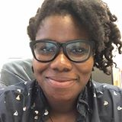

**Diversity Power Hour Lunch**

***The Adventures of Twanna Hodge (MLIS alum): From Virgin Islands, through a hurricane and back to Seattle!***

**Wednesday, November 15, 2017**

**12:30-1:30pm**

**MGH 258**

[***Please RSVP for headcount, dietary restrictions/preferences and to attend online***](https://catalyst.uw.edu/webq/survey/irecruit/342415)

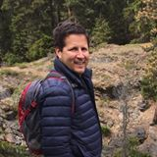

***Curriculum Transformation Project: For iSchool Faculty***

***DACA and Undocumented Students: Featuring Ricardo Gomez***

***Friday, November 17, 2017***

***12:30-1:30pm- Lunch provided!***

***MGH 258***

***[Please RSVP for headcount, dietary restrictions/preferences and to attend online](https://catalyst.uw.edu/webq/survey/irecruit/342420)***

**Week 3 events:**

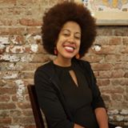

***Everyday Ally in the Workplace and Beyond: What Can I Do?***

***For iSchool Staff***

***Facilitated by*** [***Erin Jones***](https://www.linkedin.com/in/erin-jones-8a24a814/)***, Education Consultant and Community Activist***

***Monday, November 20, 2017***

***Noon-1:30pm – lunch provided!***

***MGH 258***

[***Please RSVP for headcount, food restrictions/preferences and to attend online.***](https://catalyst.uw.edu/webq/survey/irecruit/341904)

**UW HOLIDAY! Thursday & Friday, Nov. 23 & 24, 2017- Thanksgiving break**

**Week 4:**

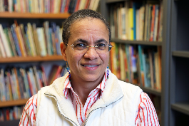

***iEquality Diversity Power Hour Lunch***

***Like Raindrops on Granite: A Dialogic Analysis of Full Cicada Moon as Crossover Scholarship***

***featuring Dr. Michelle Martin and Liz Mills***

***Wednesday, November 29, 2017***

***12:30-1:30pm***

***MGH 258***

***[Please RSVP for headcount, dietary restrictions/preferences and to attend online](https://catalyst.uw.edu/webq/survey/irecruit/343628)***

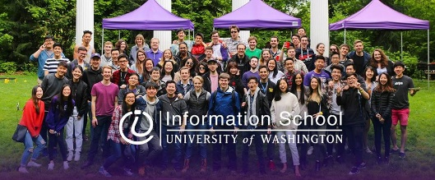

***Diversity Power Hour Lunch***

***INFO Recruitment Planning Lunch***

***Thursday, November 30, 2017***

***12:30-1:30pm***

***MGH 258***

[***Please RSVP for headcount, dietary restrictions/preferences and to attend online***](https://catalyst.uw.edu/webq/survey/irecruit/342416)

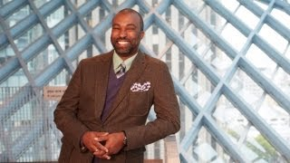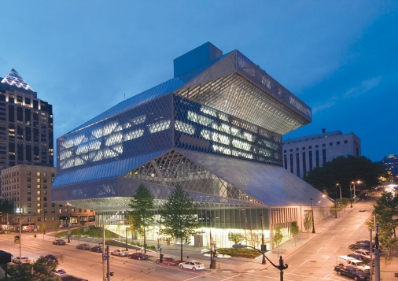

***ALISS invites you to***

***Where Will Your Passions Take You?***

**ALISS and Seattle Public Library (SPL) Present:**

***Marcellus Turner, SPL Executive Director and Chief Librarian***

***Clotia Robinson, SPL Human Resources Business Partner***

***Tess Wilder-Cervantes, UW MLIS alum and SPL Youth Librarian***

**Friday, December 1, 2017**

**12:30 p.m. to 1:30 p.m. – *lunch provided; seating is limited;*** [***RSVP required***](https://catalyst.uw.edu/webq/survey/irecruit/342418)***!***

**\*\*Room Change** Allen Library Petersen Room, Room 485**

**[Please RSVP for headcount, dietary restrictions/preferences and to attend online](https://catalyst.uw.edu/webq/survey/irecruit/342418)**  
<https://catalyst.uw.edu/webq/survey/irecruit/342418> **To attend online, please RSVP by Nov. 28**

**Join us for this diversity recruitment and professional development event and learn how YOU can serve your community and live your passions everyday as an employee at The Seattle Public Library.**

***To attend events online, please RSVP at least three business days prior to the event.***

**To request disability accommodation, contact the Disability Services Office at 206-543-6450 (voice), 206-543-6452 (TTY), 206-685-7264 (fax), or**[**dso@uw.edu**](mailto:dso@uw.edu)**, preferably at least 10 days in advance of the event.**